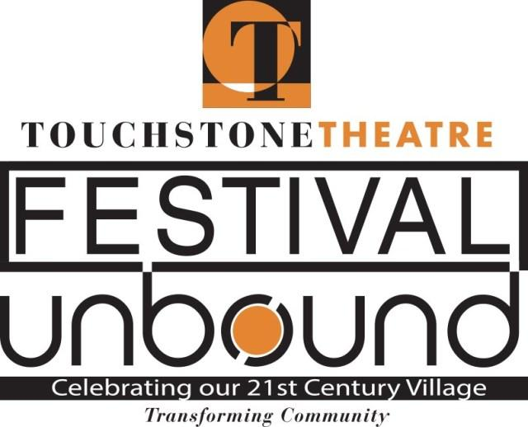

FOR IMMEDIATE RELEASE
September 16, 2019
Contact: Lisa Jordan
610.867.1689 / lisa@touchstone.org

“The Secret”, New Mixed-Media Play from Mock Turtle Marionette Theatre Explores Life of Poet Hilda Doolittle

Touchstone Theatre’s Festival UnBound proudly presents Mock Turtle Marionette Theatre’s newest creation, The Secret - an exploration of the Lehigh Valley’s celebrated feminist writer and LGBTQ icon Hilda Doolittle (H.D.). Using narrative, song, and puppetry, it journeys back into Bethlehem’s past, as well as the wisdom and struggles of our mothers. Directed by Jennie Gilrain, with puppets by Doug Roysdon, The Secret takes the stage at Touchstone Theatre October 5-8, 2019.
Bethlehem native Hilda Doolittle (1886-1961) was born into the Bethlehem Moravian community, and was deeply influenced by that childhood throughout her long writing life. H.D.’s innovative and experimental poetry and prose established her as a leading Modernist writer in the early 20th century, and she is widely recognized today as a queer, feminist visionary.
The Secret begins in Bethlehem, with young Hilda walking down Church Street on a snowy winter evening in 1894 with brother Gilbert, Papa and Mama. Turning right at the church, onto Main Street, we confront a memory ... the story of how H.D.'s grandfather silenced his daughter Helen, H.D.'s mother. This silencing of Helen, and of women, becomes a central theme of the play and of H.D.s life and work as she rejects traditional feminine roles and seeks her own voice.
The script of The Secret has been devised by a creative team including Doug Roysdon, Jennie Gilrain, William Reichard-Flynn, Aidan Gilrain-McKenna, Matilda Snyder, Kalyani Singh, and Lehigh University’s Seth Moglen. H.D. is portrayed onstage by 2 actors, as well as 13 different puppets. Music was an ever-present part of H.D.’s Moravian childhood; the original music in The Secret has been composed by: Liam McKenna, Abriana Ferrari, Aidan Gilrain-McKenna, William Reichard-Flynn, Kalyani Singh, Matilda Snyder, and Tommy Gilchrist.
“I am so excited about the music in the play,” says Director Jennie Gilrain, “it’s all live: cello, trumpet, percussion (including a 1910 typewriter) and vocals. We are singing and playing J.S. Bach, Hildegard von Bingen and a Moravian hymn. However, most of the music is original, improvised and composed by a cast of extraordinary performers. I’ve had such fun watching them create such beautiful sounds to accompany H.D.’s words.”
The Secret is also part of “Finding H.D., A Community Exploration of the Life and Work of Hilda Doolittle,” a year-long series of events organized by the Lehigh University English Department, Bethlehem Area Public Library, the Bradbury-Sullivan LGBT Community Center in Allentown and Mock Turtle.
There will be a special Panel Discussion “Who Will Follow The Music? Women in Leadership: Inspirations and Obstacles", following the performance on Sunday, October 6th from 2:30 - 3:30pm. Panelists will discuss their challenges, work, and dreams; and explore ways in which we as a community can encourage women to follow their dreams.
Panelists include:
- Phyllis Alexander, Project Director of Leadership Without Limits; Senior Training Associate with the National Coalition Building Institute
- Yalitza Corsino-Davis, Learning Specialist at Lehigh Carbon County Community College
- Abriana Ferrari, composer, musician, actor, high school student and cast member in The Secret
- Mary Foltz, Professor of English at Lehigh University
- Margaret Kavanagh, Head Custodian at Freemansburg Elementary
- Nancy Matos Gonzalez, Magisterial District Judge of Northampton County in Bethlehem
- Emily Santan, ER Technician, Sacred Heart Hospital Emergency Room, Allentown
- Paige Van Wirt, Bethlehem City Councilwoman and Physician with LV Health Network
There will also be a TalkBack following the Saturday, October 5th performance from 6:30 - 7:00pm.
“THE SECRET” PERFORMANCE SCHEDULE:
Saturday, October 5 – 5:00-6:30p | Talkback 6:30-7:00pm
Sunday, October 6 – 1:00-2:30p (Audio Description) | Panel 2:30-3:30pm
Monday, October 7 – 7:30-9:00pm
Tuesday, October 8 – 7:30-9:00pm

Tickets are $25 adult & $15 student/senior; limited amount of Pay What You Will tickets for purchase.

Touchstone Theatre is one of the country’s longest continuously-producing ensemble theatres. Festival UnBound is a ten-day community convergence featuring over 20 free and ticketed events October 4-13, 2019. As part of Touchstone’s mission of community-building, Festival UnBound uses art to spark conversation about how the city has changed in the 20 years since the closing of Bethlehem Steel and to imagine our future together.
For more information on Festival UnBound, to purchase Festival tickets or a Festival Pass, visit www.festivalunbound.com, or call 610-867-1689. Touchstone Theatre is located at 321 E. Fourth Street, Bethlehem, PA, 18018.
# # # -------------------------------------
“THE SECRET” PRODUCTION INFO:

Production Staff:
Doug Roysdon, chief writer and puppet maker
Jennie Gilrain, director
Liam McKenna, chief composer
Larry Lipkis, musical consultant
Ree Harrington, costume designer
Melpomene Katakalos, set designer
Ara Barlieb, lighting designer
Seth Moglen, historical and literary adviser

Music composed by: Liam McKenna, Abriana Ferrari, Aidan Gilrain-McKenna, William Reichard-Flynn, Kalyani Singh, Matilda Snyder, and Tommy Gilchrist

Script devised by: Doug Roysdon, Jennie Gilrain, William Reichard-Flynn, Aidan Gilrain-McKenna, Matilda Snyder, Kalyani Singh, and Seth Moglen

Performers:
Abriana Ferrari, actor-puppeteer-singer
Aidan Gilrain-McKenna, actor-puppeteer-singer
Tommy Gilchrist, cello
Madison Ledergerber, actor-puppeteer-singer
Liam McKenna, trumpet
William Reichard-Flynn, actor-puppeteer-singer
Matilda Snyder, actor-puppeteer-singer
Grace Adele Spruiell, actor-singer, percussion, harp

