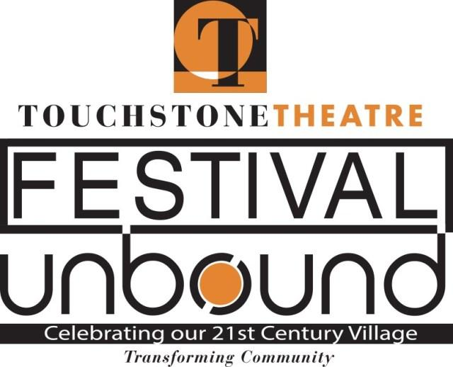
Sustainability Forum to explore working together for a healthy community

Touchstone Theatre of Bethlehem is holding a Sustainability Forum 1-3 p.m. Oct. 12 at Zoellner Arts Center at Lehigh University in Bethlehem to brainstorm, debate, and discuss how to work together to create a healthy and connected community.
The Sustainability Forum will feature comments and ideas from students, workers, business leaders, politicians, professors and other pillars of the community. It will empower local citizens to take action for a more eco-friendly future and respond to its challenges. Admission is free.
The event is part of Festival Unbound, a 10-day community convergence Oct. 4-13 featuring more than 20 free and ticketed events, including nine original theater pieces, at venues through the Lehigh Valley. The goal of the festival is to use art to generate conversation about what Bethlehem should look like 20 years after the closing of Bethlehem Steel.
A new theater piece by Agile Rascal Bicycle Touring Theater, “The Hunt for Utopia,” will take audiences on a wild ride, literally, through Bethlehem. The piece will be presented Oct. 8-12, beginning at the Charles A. Brown Ice House in Bethlehem. Tickets are $15 for adults; $10 for students and seniors. Pre-registration is required for audience members to secure their own bikes, which they will ride with the troupe of champions for green transport and adventure.
For more information, see www.festivalunbound.com or call 610-867-1689.

