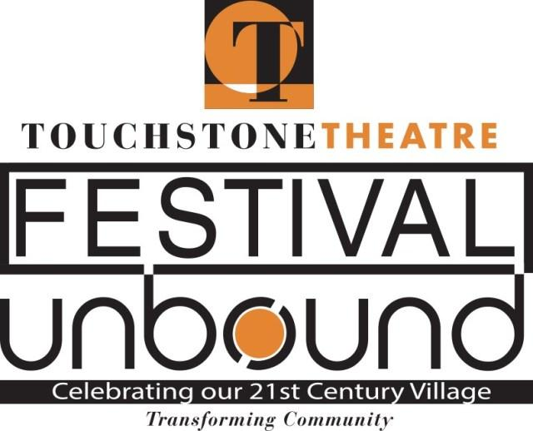
FOR IMMEDIATE RELEASE
Contact: Lisa Jordan
610-867-1689 / lisa@touchstone.org

Local youth take on a monster in Touchstone production of
‘Starry-Eyed,’ part of Festival UnBound

On Oct. 5 and 6, local teenagers will take over Payrow Plaza in Bethlehem to do battle with a mythological monster– and conquer their fears and insecurities– as they envision a great future.
The 14 teens from Bethlehem’s Liberty and Freedom high schools and the Lehigh Valley Charter High School for the Arts bring a strong chorus of youth voices to Starry-Eyed, an original play that is part of Festival UnBound, a 10-day convergence of art and community designed to spark conversation about the future of Bethlehem 20 years after the closing of Bethlehem Steel.
Starry-Eyed will be presented outdoors on the first weekend of the festival, which runs Oct. 4-13 and includes nine original pieces of theater, along with visual art, street spectacles and opportunities for conversation.
Festival organizers wanted a strong youth voice in the festival. “They are our tomorrow,” says Starry-Eyed director Emma Ackerman, a member of the Touchstone Theatre ensemble and coordinator of Touchstone’s Teen Ensemble.
The script and music for Starry-Eyed were written by the students in the production. To get started, they played theater games, brainstorming about their worries – being accepted, being heard, anger, fear of not finding love, global warming – and about their hopes and dreams for the future.
In the play, they find the answers in each other and in their art.
The storyline is that they are “a wandering group of weirdos on a journey together,” says Ackerman. They stumble upon Bethlehem, a place they kind of have heard about, and find a connection to.
But there is something in Bethlehem they must do battle with -- a nameless beast that preys on their insecurities. It will be represented by a puppet created by Kyra Zimmerman, a student at Charter Arts.
They fail at times, but persevere.
The students are stoked to present the results of a year of work.
“We’ve been working on this for such a long time, writing and rewriting and creating it all little by little,” says Emma Engler, a student at Charter Arts. “It’s so exciting to see all the bits and pieces finally being to fit together to make this beautiful performance.”
Says Jolie Lanning, another Charter Arts student: “Being part of the youth piece has made me realize how important arts and my role as a teen is in the community. I hope everyone who comes will be touched by our work and see how important the youth voices are here in Bethlehem.”
Starry-Eyed will be presented at 11 a.m. Oct. 5 and 6 at Payrow Plaza, 10 E. Church St. Suggested donation is $15, adults; $10, students and seniors.
For tickets, go to Festivalunbound.com or call 610-867-1689.
OTHER YOUTH ACTIVITIES at Festival UnBound include:
*pARTicipate: Express Yourself: Art activities at the Bethlehem Area Public Library designed to express hopes and dreams for the future. Help fiber artist Mallory Zondag create a fiber mural based on images created by Bethlehem Area School District fourth graders who spent last year imagining a better future for the community. The mural will eventually hang from City Hall. Watch for the art on display at various locations during Festival UnBound. Paint everyday kitchen implements to be added to an outdoor sculpture. Write your hopes and dreams on ribbons to be added to “gateways to dreams” for the closing ceremony. Create upcycled art that celebrates sustainability. Saturdays, Oct. 5 and 12, and Oct 7-11, 10 a.m.-noon and 2-5 p.m., Bethlehem Area Public Library, 10 E. Church St., Bethlehem. Free.
*Inside/Outside City: Music, recreational and artistic events for public participation, including nerd games, comics jam, athletics, yoga, poetry, art making, 11 a.m.-2 p.m. Wednesday Oct. 9, South Bethlehem Greenway, 100, 200 and 300 blocks. Free.

