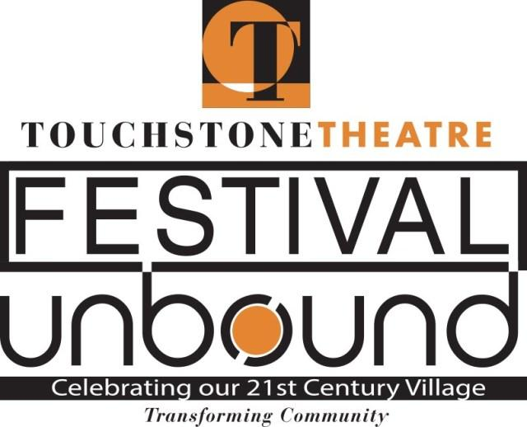
‘Kitchen Chronicles’ to bring people together at a common table
Performance art piece one of nine original productions to be presented by Touchstone Theatre in upcoming Festival UnBound in Bethlehem

An original theatrical piece created by Mary Wright of Bethlehem aims to bring people together in the kitchen to discover how much they have in common.
Kitchen Chronicles will be presented Oct. 6 and 7 in the show kitchen at the PBS39 building at SteelStacks. The performances are part of Touchstone Theatre’s Festival UnBound, a 10-day artistic community convergence, featuring more than 20 free and ticketed events designed to spark conversation and explore ideas for the future of Bethlehem 20 years after the closing of Bethlehem Steel. The festival runs Oct. 4-13.
“It’s not just about food. It’s about heritage. It’s about memory. It’s about bringing people together at a community table,” says Wright, a Touchstone Theatre ensemble member, about Kitchen Chronicles. “When we sit down and eat together, a different kind of conversation happens.”
The show will be part cooking demonstration, part performance, and part fellowship. It aims to blur the line between audience and performer. Wright will lead the event -- “Imagine I invited you all over to my house and I just happened to have a TV show worthy kitchen in it,” she says.
Wright will tell stories about her life in the kitchen and try to illicit stories from audience members – the idea is to share wisdom gleaned from time spent in the kitchen. Wright will demonstrate how to make pizza dough from scratch – and talk about her grandma’s secret to great baking. Ultimately, the dough will be turned into a delicious dessert pizza with apple pie filling and oatmeal crumble. Show-goers will get to try it.
During the event, Wright’s husband Ben and the couple’s friend, “Binomia” Bill Schacter will play guitar and sing some songs.
“At my house when friends get together, we often pull out guitars. We enjoy making music as much as we enjoy cooking and making memories.”
The work fits into the overall festival themes of uniting diverse communities and finding the sacred in the ordinary. “All of these overlooked things in life-- that when you take the time to stop and notice, and pay attention, you see how important they are,” says Wright.
Wright got the idea for Kitchen Chronicles from a workshop she did with Jay O’Callahan, a master storyteller. He told participants to visualize a kitchen they know well and to latch onto a kitchen implement. They explored the backstory of the kitchen and wrote monologues on the history of the kitchen implement.
“The things we talk about in a kitchen. The kinds of conversations we have. Some of the most important things that happened to me in life happened in a kitchen,” she says.
To prepare for the piece, Wright first gathered stories – a common way that Touchstone begins many of its pieces. She interviewed people about their memories of time spent in the kitchen. How they learned to cook. What they loved about it. Why is eating together important. She gathered 24 hours of interviews with people here and around the world, including the head butler of Christ Church in Oxford, which houses the famous 16th century hall used as a model for the dining hall in the “Harry Potter” films.
As a result, people started inviting Wright into their kitchens and she brought early renditions of this performance piece to eight homes.
“Somebody opening up their kitchen to you is an honor,” she says. “Kitchens are the most intimate parts of a family home. It really is the heart of the home.”
While the people in the private homes knew each other, they learned a lot about each other that they didn’t know, Wright says.
Of how the event ties into Festival UnBound, Wright says: “The foods we eat may be different. We may like to cook or not like to cook. But we all eat and somebody is making the food for us. By having everyone at a common table, it’s a way of reminding us of our commonalities. The things that tie us together.”
“I really want to see what happens when you get people and food in a kitchen-like setting and how that creates community.”
Among the other original works to be presented at Festival UnBound are:
Prometheus/Redux, a world premiere of commissioned play, written by Gerard Stropnicky. It marks the 20th anniversary of Bethlehem Steel’s closing and is a companion piece to the seminal work Steelbound from Touchstone’s 1999 Steel Festival.
Hidden Seed: Bethlehem’s Forgotten Utopia, written by Touchstone Theatre founder Bill George and Lehigh University’s Seth Moglen. Hidden Seed explores Bethlehem’s birth and how it can strengthen our future by unearthing the stories of multiculturalism and women’s rights.
Starry-Eyed, devised and written by teens from Bethlehem high schools about a group of misfit heroes who find themselves in Bethlehem by accident but stay to fight the monsters they find there – and face their own fears.
To Hunt a Wild Utopia, a commissioned work by Agile Rascal Bicycle Touring Theatre that will take audiences on a wild theatrical ride, literally, through Bethlehem on a quest for utopia.
Touchstone Theatre is one of the country’s longest continuously-producing ensemble theatres. Festival UnBound is part of Touchstone’s mission of community-building.
Kitchen Chronicles is sponsored by PBS 39 and Morris Black Designs.
Show time for Kitchen Chronicles is 7-8:30 p.m. Tickets are $20. For tickets to Kitchen Chronicles and other Festival UnBound productions, visit www.festivalunboundcom or call the Touchstone Box Office at 610-867-1689.

More info on Kitchen Chronicles – contact Mary Wright at mary@touchstone.org or 484-767-2456.

