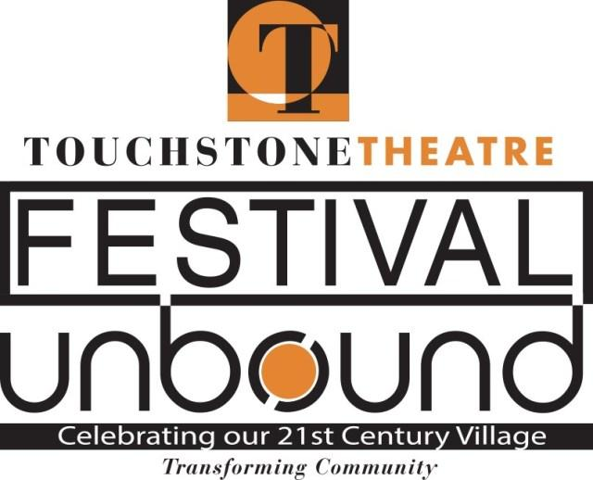
FOR IMMEDIATE RELEASE
September 15, 2019
Contact: Lisa Jordan
610.867.1689 / lisa@touchstone.org

FESTIVAL UNBOUND’S “POETS, TROUBADOURS, AND TROUBLEMAKERS” SHOWCASES NEW HOME-GROWN MUSIC AND MUSIC MAKERS, OCTOBER 9-11
Touchstone Theatre’s Festival UnBound and Godfrey’s Daniels are presenting Poets, Troubadours, and Troublemakers throughout the Lehigh Valley October 9-11, three evenings of live original music created in the spirit of Festival UnBound’s mission of envisioning our future home.
Touchstone Theatre’s groundbreaking Festival UnBound is a ten-day community convergence featuring more than 20 free and ticketed events October 4-13, 2019. Festival UnBound uses art to spark conversation about how the city has changed in the 20 years since the closing of Bethlehem Steel, and to imagine our future together.
Under the direction of renowned folk musician Anne Hills, Poets, Troubadours and Troublemakers began as a six-month bi-weekly series of public songwriting workshops at Godfrey Daniels, featuring a fabulous line-up of nationally known workshop leaders drawn from the Godfrey’s music community, including John Gorka, Tish Hinojosa, Erin McKeown, and mother and daughter team Suzzy Roche & Lucy Wainwright Roche. Valley-based workshop leaders included songwriters Alex Radus, Jack Murray, and spoken word artist Deirdre Van Walters.
Workshop participants Andrew Dunn, Amanda Penecale, Katherine Rondeau, and Rhys Williams will perform their new workshop-created work at three Festival UnBound concert events throughout the Valley:
- Wednesday, October 9 – 7:00-8:30pm at The Sigal Museum, 342 Northampton Street in Easton.
- Thursday, October 10 – 7:00-8:30pm at The Lyric Room at Miller Symphony Hall, 23 N. Sixth Street in Allentown
- Friday, October 11 – 8:00-9:30pm at Godfrey Daniels, 7 E. Fourth Street, Bethlehem. *Panel discussion follows performance
All four of the workshop artists will perform their new pieces at the concerts, along with guest appearances from Anne Hills, Alex Radus and Jack Murray. There is a Guest Panel Discussion following the final October 11 concert at Godfrey Daniels, providing an opportunity for audience feedback and Q&A.
Poets, Troubadours, and Troublemakers Coordinator Anne Hills says:
“This project has been fun, encouraging and ultimately inspiring. From the beginning we had a core group of writers who were anxious to listen, grow into the work and enthusiastic about the goals Festival Unbound set for us. Writing from a sense of Place.
We had a stellar line-up of veteran songwriters to bring ideas, including nationally recognized musicians like John Gorka, Erin McKeown, mother and daughter Suzzy Roche and Lucy Wainwright Roche, southwestern writer Tish Hinojosa, as well as, local songwriters Alex Radus, Jack Murray and spoken word artist Deirdre Van Walters, and a guest appearance of David Roth.
All these, along with more intensive group sessions where we listened and gave feedback over 12 weekends. We finished with a recording session at Godfrey Daniels featuring songs that we hope have captured Bethlehem’s past and future spirit.”
A CD featuring the new works born out of the Poets, Troubadours, and Troublemakers workshops has been recorded by Jason Reif of Freestone Productions and will be available at all three concerts.
Concert Tickets are $15 and can be reserved at www.festivalunbound.com, or by calling the Touchstone Box Office at 610-867-1689.
Touchstone Theatre is one of the country’s longest continuously-producing ensemble theatres. Festival UnBound is part of Touchstone’s mission of community-building. For more information on Festival UnBound, to purchase Festival tickets or a Festival Pass, please visit www.festivalunbound.com.

“POETS, TROUBADOURS, AND TROUBLEMAKERS” DATES & TIMES:
Wednesday, October 9 – 7:00-8:30pm (@ The Sigal Museum | 342 Northampton Street, Easton, PA)
Thursday, October 10 – 7:00-8:30pm (@ The Lyric Room, Miller Symphony Hall | 23 N. Sixth Street, Allentown, PA)
Friday, October 11 – 8:00-9:30pm (@ Godfrey Daniels | 7 E. Fourth Street, Bethlehem, PA) *Panel discussion follows performance
VENUES: The Sigal Museum | 342 Northampton Street, Easton, PA
The Lyric Room, Miller Symphony Hall | 23 N. Sixth Street, Allentown, PA
Godfrey Daniels | 7 E. Fourth Street, Bethlehem, PA
PRICE: $15; limited amount of Pay What You Will tickets for purchase; please call 610-867-1689 to order or www.festivalunbound.com

# # #

