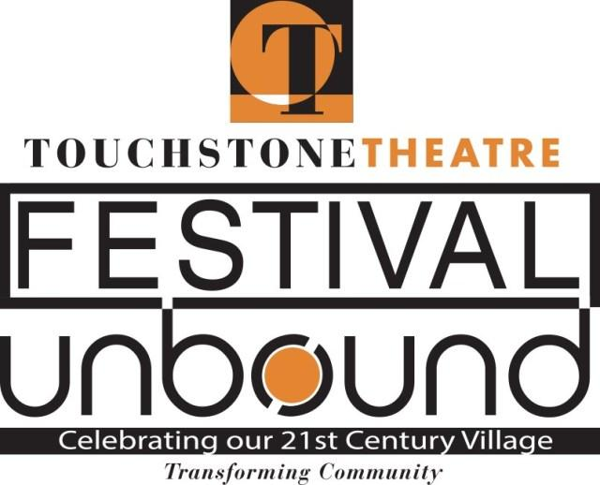
Agile Rascal presents wild ride, literally, through Bethlehem as part of Festival UnBound
Touring bicycle theater company presents new, participatory work as part of Touchstone Theatre’s 10-day theater and art festival

Picture this.
A team of actors on decorated bicycles lead a procession of “audience members,” also on bicycles, as they ride through the city and explore the “utopia” that could be found in the City of Bethlehem.
That’s what will happen in early October when Agile Rascal, a California-based bicycling touring theater, presents an original musical theatrical work commissioned by Touchstone Theatre of Bethlehem as part Festival UnBound: A 10-day community convergence of original theatre, dance, music, art and conversation Oct. 4-13 created to celebrate and imagine the future of Bethlehem.
Agile Rascal will present “To Hunt a Wild Utopia,” a wild 2.5-mile theatrical ride beginning and ending at the Charles A. Brown Ice House. There will be eight performances Oct. 9-12. Tickets are $15 for adults; $10, students and seniors, with a limited number of Pay-What-You-Will tickets available. Pre-registration is required and bicycles will be provided.
Agile Rascal is known for creating original plays and touring them on bicycles to engage creative thinking about our collective future and promote green transport. The troupe formed in 2014; in 2015, seven artists crossed the country on bikes, carrying everything needed to tour its inaugural original work.
Since then, Agile Rascal has presented smaller, regional tours. “To Hunt a Wild Utopia” represents a brand new type of project for the group – one created for a specific community and one in which the audience acts as much more than spectators.
“Teaming up with Touchstone, whose mission is to create original and adventurous works that explore issues related to the community, made a lot of sense,” says Dara Silverman, Agile Rascal founder and artistic director. Both groups are interested in making art that serves communities and environmental issues.
Silverman and production manager/performer Jackie Rivera came to Bethlehem in May to learn about Bethlehem, get a lay of the land, and map out a route. They learned about the Moravian people, the steel industry, and the revitalization of industrial property. Silverman wrote the work when she returned to California.
The best way to describe the production, Silverman says, is like a fox hunt. Bicycles will be decorated like horses as the group sets out to search Bethlehem for “utopia,” which is a “nebulous, mystic thing,” “sort of like an animal,” and “sort of like an idea.” The idea is that everyone has a different perception of what utopia is and how do you find it.
There will be stops during the ride where participants will meet new characters. The production includes original music played by some of the actors, as well as pre-recorded music.
Audience participation and discussion will be included, but not required, beyond riding the route.
Participants don’t have to be great riders – the route is mostly flat and very accessible.
Each ride will feature six actors and up to 20 people will be able to participate.
Bikes are being provided by Bike Bethlehem, a bike share program, and CAT, the Coalition for Alternative Transportation.
“To Hunt a Wild Utopia” is one of nine original theater pieces among the 20 free and ticketed events that are part of Festival UnBound. Festival UnBound uses art to spark conversation about how the city has changed in the 20 years since the closing of Bethlehem Steel and to imagine our future together now that we are “unbound” from the Steel.
The festival is a sequel to Touchstone’s groundbreaking Steel Festival presented in 1999. It is organized in collaboration with the City of Bethlehem, local African American and Latinx communities, educational institutions such as the Lehigh Valley Charter High School for the Arts and Moravian College and area steelworkers and other residents. In addition to theater, events include music, visual art, youth activities, street performances and community conversations. About half of the events require tickets; many are free.
“To Hunt a Wild Utopia” is sponsored by Air Products, fig and Camel’s Hump Farm on the Johnston Estate.
For more information and tickets, see www.festivalunbound.com or call 610-867-1689.

CONTACT:
Lisa Jordan, Touchstone managing director: 610-867-1689, lisa@touchstone.org
Dara Silverman, Agile Rascal founder: 339-927-0675, dara.silverman@gmail.com

