FOR IMMEDIATE RELEASE
August 5, 2019
Contact: Lisa Jordan
610.867.1689
lisa@touchstone.org
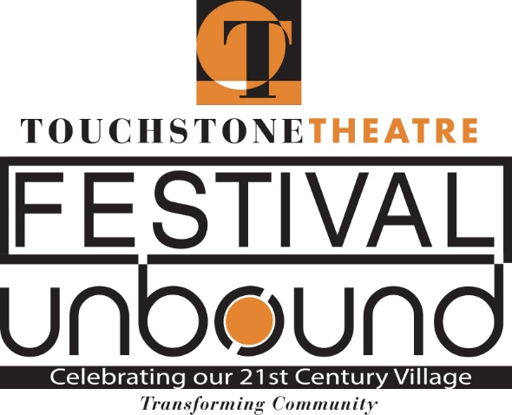

Schedule set; tickets on sale for ten-day Festival UnBound, October 4-13 in Bethlehem
After more than two years of planning, the schedule is set and tickets are now on sale for Touchstone Theatre’s ten-day Festival UnBound, a community convergence featuring more than 20 free and ticketed events October 4-13, throughout the Lehigh Valley but primarily held in the City of Bethlehem. Festival UnBound uses art to spark conversation about how the city has changed in the 20 years since the closing of Bethlehem Steel and to imagine our future together now that we are “unbound” from the Steel.

The groundbreaking festival, organized in collaboration with the City of Bethlehem, local African American and Latino communities, educational institutions such as the Lehigh Valley Charter High School for the Arts and Moravian College, and area steelworkers and other residents, will include nine pieces of original theater by local, national, and internationally known artists; music; visual art; parades; youth activities; street performances; forums for conversation, and more. Events are both indoors and outdoors at venues such as Touchstone Theatre, Zoellner Arts Center, Charles A. Brown Ice House, Bethlehem Area Public Library, Lehigh Valley Charter High School for the Arts, South Bethlehem Greenway, and Payrow Plaza. About half of the events require tickets; many are free.

Events with set ticket prices include “Prometheus/Redux,” a new play by Gerard Stropnicky that picks up where Touchstone Theatre’s “Steelbound” ended 20 years ago. “Steelbound” was the centerpiece of the company’s Steel Festival in 1999, a multi-arts festival that celebrated Bethlehem’s heritage of steel making. In the new work, Bill George, Touchstone Theatre co-founder and ensemble member, returns as the steelworker Prometheus. He has been missing for 20 years, and we find him in a hospital bed. Where has he been? What’s on his mind? And how can he find a place for himself in such a changed world?

Other ticketed events include “A Joyful Noise,” a collaborative concert between the Bach Choir of Bethlehem and community choirs celebrating the joy of creating music together; “The Hunt for Utopia”, an interactive performance event with Agile Rascal - an innovative bicycling theatre troupe that will take ticketholders on a ride through the city; and “The Secret,” a new play by Mock Turtle Marionette Theater on the Lehigh Valley’s most influential artist, the celebrated feminist writer and LGBTQ icon Hilda Doolittle. A limited number of Pay What You Will tickets will be available for these events.

Some events are Pay What You Will exclusively, with a suggested ticket price, such as “Forward March: The Future of Our Warriors,” an original production by Women Veterans Empowered & Thriving, featuring poetry, storytelling, and theater designed to bridge the gap between veterans and civilians; “Beyond Utopia,” an original piece by visiting Polish company Teatr Brama and Moravian College students, exploring themes of poverty and inequality in pursuit of a new vision for Bethlehem; and “Starry-Eyed,” an original production devised and written by teens from Bethlehem high schools about an eclectic band of travelers learning to fail successfully.

Free events at Festival UnBound include “Homecoming,” a celebration of African American culture; the Opening and Closing ceremonies; a Sustainability Forum; and a Community Dinner.

Festival passes also are available for purchase, offering a 25% savings off the regular ticket prices for those wishing to attend many events.

“Festival UnBound and its many offerings are made by and for our local community,” says Touchstone Theatre Artistic Director Jp Jordan. “To complete the circle, we need to share the conversation and the Festival with as many people in the community as possible. We hope that those who need it will take full advantage of the Pay What You Will ticket prices and those that don’t will pay full price.”

Accessibility to Festival UnBound events is directly connected to its mission. By setting tickets prices that allow potential audience members of any means to attend as many of the events as possible, Touchstone hopes to include the greatest range of audience as possible in this arts and civic endeavor. Additionally, in partnership with the Lehigh Valley Center for Independent Living and with support from the Lehigh Valley Arts Council Arts & Access program, Festival UnBound will offer audio description and sign language interpretation for select performances. Festival venues are wheelchair accessible, with the exception of a performance in the historic Single Sisters House that explores how Bethlehem’s roots can strengthen our future. Because of that a performance of the work, “Hidden Seed: Bethlehem’s Forgotten Utopia,” will also be held at PBS 39 on the SteelStacks campus. Patrons with accessibility concerns should contact Lisa Jordan at Touchstone Theatre at lisa@touchstone.org or 610-867-1689.

Touchstone Theatre is one of the country’s longest continuously-producing ensemble theatres. Festival UnBound is part of Touchstone’s mission of community-building. Other groundbreaking community-based works have included “Don Quixote of Bethlehem,” a street production designed to bridge the gap between the Anglo and Latino cultures, and “Journey From the East,” a two-year project inspired by the growing resident and transient Chinese community in Bethlehem.

To order Festival UnBound tickets or to purchase a festival pass visit www.festivalunbound.com or call the Touchstone Box Office at 610-8671689.

Festival UnBound Schedule of Events:
* Festival UnBound Opening Ceremony, a celebratory processional down the South Bethlehem Greenway with live music, pageantry, drama and civic pride sending off this festival of arts and civic dialogue. 5:30-7 p.m. Oct. 4, South Bethlehem Greenway. Free; donations welcome.
* “Prometheus/Redux,” world premiere of original play commissioned for Festival UnBound, written by Gerald Stropnicky. Marks the 20th anniversary of Bethlehem Steel’s closing and is a companion piece to the seminal work “Steelbound” from Touchstone’s 1999 Steel Festival. Oct. 4-6, Lehigh Valley Charter High School for the Arts, 321 E. Third St., Bethlehem. Tickets: $25, adults; $15, students, seniors, steelworkers; limited number of Pay What You Will tickets available.
* Festival UnBound Cabaret, an evening watering hole with food and drinks, ambiance and conversation, where the Festival audience can rendezvous and enjoy performances by some of the area’s unique musical and performing artists. Oct. 4-6, 11-12, Touchstone Theatre parking lot at 321 E. Fourth St., Bethlehem. Free.
* “Homecoming,” an afternoon gathering highlighting the Black community in the Lehigh Valley, with spoken word poets, live music, African drumming, speakers, ethnic food, and vendors. Noon-5 p.m. Oct. 5, Bob Cohen Room, Bethlehem Area Public Library, 11 W. Church St. Free; donations accepted.
* “Hidden Seed: Bethlehem’s Forgotten Utopia,” original production written by Touchstone Theatre’s founder Bill George and Lehigh University’s Seth Moglen exploring Bethlehem’s birth and how it can strengthen our future by unearthing the stories of multiculturalism and women’s rights sown into our soil and other treasures left by our forebears. Oct. 5-9, Single Sisters House, 50 W. Church St., Bethlehem (limited handicapped access), and Oct. 10, PB S39, SteelStacks, 839 Sesame Street, Bethlehem (handicapped accessible). Tickets: $20; limited number of Pay What You Will tickets available.
* “Starry-Eyed,” original production devised and written by teens from Bethlehem high schools about a group of misfit heroes who find themselves in Bethlehem by accident but stay to fight the monsters that they find there – and face their own fears. Noon-1:30 p.m. Oct. 5-6, Payrow Plaza, 10 E. Church St, Bethlehem. Tickets: Pay What You Will: Suggest donation of $15, adults; $10, students and seniors.
* “The Secret,” premiere of a play by Mock Turtle Marionette Theater on the Lehigh Valley’s most influential artist, the celebrated feminist writer and LGBTQ icon Hilda Doolittle, featuring narrative, song and puppetry. Oct. 5-8, Touchstone Theatre, 321 E. Fourth St, Bethlehem. Tickets: $25, adults; $15, students and seniors; limited number of Pay What You Will tickets available.
* “Kitchen Chronicles,” immersive and delicious performance led by Touchstone Ensemble member Mary Wright that offers a one-of-a-kind take on the powers of food and wisdom shared in the kitchen. 7-8:30 p.m. Oct. 6-7, PBS 39, SteelStacks, 839 Sesame St., Bethlehem. Tickets: $20; limited number of Pay What You Will tickets available.
* “A Joyful Noise,” featuring the Bach Choir in collaboration with Nazareth High School Choir, Camille Armstrong, Shiloh Baptist Choir, Big Easy Easton Brass, Ysaye Barnwell of Sweet Honey in the Rock, Lehigh Valley Charter High School for the Arts Choir, Bel Canto Youth Chorus and Jakopa’s Punch. Explores how the collective act of music making can bring people together. 4-6 p.m. Oct. 6, Zoellner Arts Center, Baker Hall, Lehigh University, 420 E. Packer Ave., Bethlehem. Tickets: $15, adults; $10, students; limited number of Pay What You Will tickets available.
* “Beyond Utopia,” visiting Polish company Teatr Brama leads Moravian College undergraduate students and graduate students from the new Moravian/Touchstone MFA program in Performance Creation in an original work developed for the festival exploring themes of poverty and inequality in pursuit of a new vision for Bethlehem. Oct. 7-8, Bethlehem Area Public Library, 11 W. Church St., Bethlehem. Pay What You Will: Suggested donation of $10, adults; $5, students and seniors.
* “Community Conversations,” this noontime series will explore festival themes in a relaxed environment, moderated by Touchstone Ensemble member/Moravian College professor Christopher Shorr. Noon-1 p.m. Oct. 7-11, Café the Lodge, 427 E. Fourth St., Bethlehem. Free; food available for purchase.
* “The Inside/Out City,” a midweek, daytime event filled with music, dance, visual arts, games and conversation based around the Festival themes and built for community participation. 10 a.m.-2 p.m. Oct. 9, Locations TBA, Free.
* “The Hunt for Utopia,” a new commissioned work by Agile Rascal Bicycle Touring Theatre will take audiences on a wild theatrical ride, literally, through Bethlehem on a quest for utopia. Ticket-holders will ride with the troupe of champions for green transport and adventure. Oct. 9-12, beginning at Charles A. Brown Ice House, 56 River St., Bethlehem. Tickets: $15, adult; $10, students and seniors; limited number of Pay What You Will tickets available. Pre-registration is required; bicycles provided.
* “Poets, Troubadours, and Troublemakers,” three evenings of live, original music, created in the spirit of Festival UnBound and dedicated to the Festival’s mission of envisioning our future home. A collaboration with Godfrey Daniels and folk musician Anne Hills. Oct. 9, Sigal Museum, 342 Northampton St. Easton; Oct. 10, The Lyric Room, Miller Symphony Hall, 23 N. Sixth St., Allentown; Oct. 11, Godfrey Daniels, 7 E. Fourth St, Bethlehem. Tickets: $15; limited number of Pay What You Will tickets available.
* “Forward March: The Future of Our Warriors,” original production by Women Veterans Empowered & Thriving featuring poetry, storytelling and theater designed to bridge the gap between veterans and civilians. Oct. 9-10, Touchstone Theatre, 321 E. Fourth St., Bethlehem. Pay What You Will: Suggested donation of $15, adults: $10, students, seniors and veterans.
* Sustainability Forum, a town hall-style gathering to brainstorm how to create a healthy and connected community. 1-3 p.m. Oct. 12, Zoellner Arts Center, Lehigh University, 420 E. Packer Ave., Bethlehem. Free; donations accepted.
* “Embracing Bethlehem/Abrazos a Belén,” original site-specific theatrical experience of song and story by New York’s pre-eminent Latino theatre collective Pregones developed in partnership with Bethlehem’s Latino community. Oct. 11-12, Charles A. Brown Ice House, 56 River St., Bethlehem. Pay What You Will: Suggested donation $15, adults; $10, students and seniors.
* Community Meal & Epilogue, an opportunity to savor Bethlehem favorite foods, hear live music and share takeaways from the Festival UnBound experience. 2-5 p.m. Oct. 13, Charles A. Brown Ice House, 56 River St. Bethlehem. Free (food included); donations welcome.
* Closing Ceremony, an outdoor extravaganza of our 21st century village, with song, dance, spectacle and hopes for a bright future. 5:30-7 p.m. Oct. 13, Payrow Plaza, 10 E. Church St., Bethlehem. Free; donations welcome.

###
“Steelbound" (1999); Bill George as Prometheus. He resurrects this character in "Prometheus/Redux" for Festival UnBound.

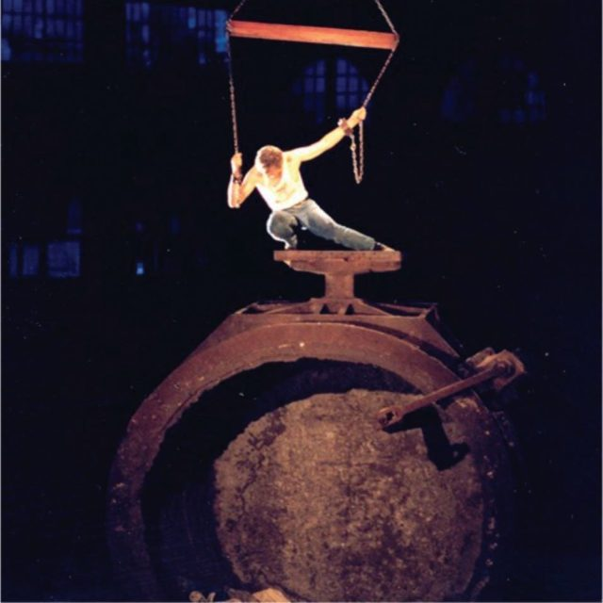
Agile Rascal Bicycle Touring Theatre (featured below) visits Bethlehem to perform new work commissioned for Festival Unbound called “ The Hunt for Utopia”.

